Review of Math Calculations
Answers
Systems Conversion Worksheet - Answers
Convert each of the given quantities to the equivalent unit indicated.

Leading zeros (0.25) are required

Trailing zeros (2.0) are incorrect

1. 1.5 g = ___1500____ mg

2. 1.5 mg = __1500____ mcg

3. 3500 g =___3.5____ kg

4. 125 mg = ___0.125__ g

5. 250 mcg = __0.25____ mg

6. 1.5 L = ___1500____ ml

7. 15 cm = ____5.9_____ in

8. 50 inches = __127_____ cm

9. 30 kg = ____66____ lbs

10. 15 t = ____75____ mL

11. 10 in = ___25.4_____ cm

12. 0.4 g = ___400____ mg

13. 220 lb = ___100____ kg

14. 5.3kg = __5300____ g

15. 3500 g = ___3.5_______ kg

16. 2 L = _2000_____ mL

17. 32 mcg = _0.032____ mg

18. 24 in = ___61_____ cm

19. 56 mcg = _0.056__ mg

20. A patient’s lunch consisted of the following fluids:

6 ounces of soup
360 mL of water
8 ounces of milk
6 ounces of gelatin
4 ounces of juice
120 mL of orange juice

Calculate the patient’s total fluid intake in ounces and mL.

_____40 oz ___1200__ mL

Oral Medications
- Order: Mirapex (pramipexole) 0.125 mg p.o. b.i.d.
Available: Mirapex 0.25 mg scored tablets.
How many tablet(s) should you administer? ______1/2 tab___________

- Order: Cytotec (misoprostol) 800 mcg p.o. to be given in 4 equally divided doses tid and hs.
Available: Cytotec 200 mcg tablets.
How many tablets should you administer each dose? ______1 tab____________

- Order: Oramorph SR (morphine sulfate) 15 mg po q 4 h prn pain. The patient received the last dose at 1500. At what time could the patient receive the medication again? ____1900_______

- Order Altace (ramipril) 5 mg po b.i.d.
Available: Altace in the figure below.
How many capsules should you administer? __________2 cap___________________

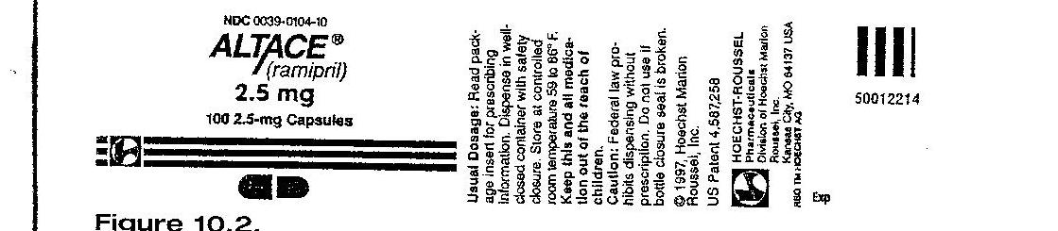

- Order Augmentin (amoxicillin/clavulanate) 800 mg oral suspension q 12h p.o.
Available: Augmentin in figure below:
Indicate on the medication cup the volume you should administer.

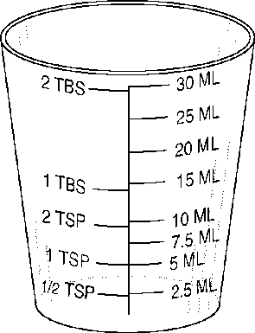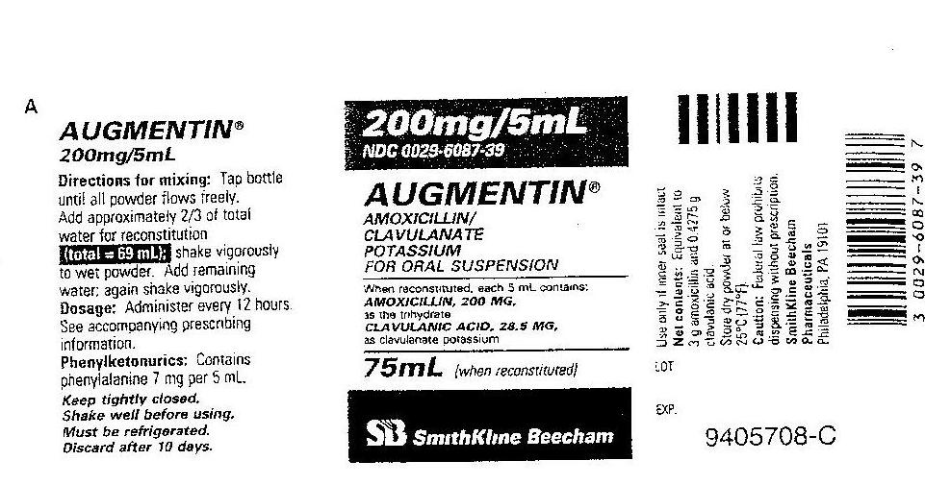
←20 mL

Parenteral Medications
- Order: Loxitan (loxapine hydrochloride) 30 mg IM q4h prn.
Available: 10 mL vial containing Loxitan 50 mg/mL.
How many mL should you administer? _______0.6 mL_____________

- Order: Procainamide hydrochloride 500 mg IM now.
Available: Procainamide vial 1 g/2mL.
How many mL should you administer? _____1 mL_________________

- Order: Valium (diazepam) 2.5 mg q 3h prn.
Available: Valium 2 mL vial containing 10 mg.
How many mL should you administer: ___________0.5 mL____________
The patient received Valium at 0300; when can the patient again receive the medication?
__________0600_____________________

- Order: Cyanocobalamin 1000 mcg IM today. Available is a multidose vial containing cyanocobalamin 10 mg/10 mL.
Mark the syringe to indicate the dose to be administered.
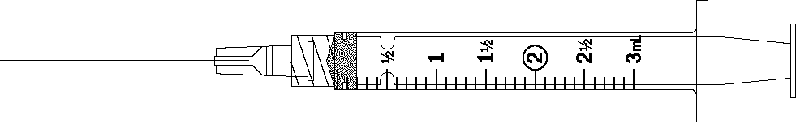
↑ 1 mL

- Order: Lovenox (enoxaparin sodium) 1 mg/kg subcut q 12h for a patient weighing 176 lbs.

Pt’s weight = 80 kg

What is the ordered dose q 12h? _________80 mg q 12h___

- Order: gentamicin 100 mg IV q 8h for a patient who weighs 220 lbs
The recommended adult dosage is 1 mg - 1.7 mg/kg/dose to be given q 8h.

Available: Gentamicin 80 mg/2 mL

Pt’s weight = 100 kg

Calculate the dose range: _____100 mg to 170 mg

Is this a safe dose? (Yes or No) ____Yes__________

If this dosage is safe, how many mL will you administer? ______2.5 mL______

- Order: Rocephin (sterile ceftriaxone sodium) 750 mg IM daily.
Available: A 1 g vial when reconstituted with 2.1 mL diluent yields a concentration of 350
mg/mL,

How many mL would you administer? _____2.1 mL__________________________

- Order: Erythromycin 750 mg IV every 6 hours.
Available: Erythromycin 1-g vial: reconstitute with 20 mL of sterile water for 1000 mg/20 mL

How many mL would you administer after reconstitution? ______15 mL_________

- Order: Fortaz 1.25 g IV every 12 h

Available: Fortaz 2 g vial; dilute each 1 g with 10 mL sterile water for final concentration of 100 mg/mL.
How many mL will you draw from the vial after reconstitution? ___12.5 mL______________

- Order: Vancomycin 275 mg IV every 8 h
Available: Vancomycin 500 mg vial; reconstitute each 500 mg vial with 10 mL NS for
final concentration of 50 mg/mL.
How many mL will you draw from the vial after reconstitution? ____5.5 mL__________

Concentration problems

- Heparin sodium 25,000 units in 250 ml D5W. What is the concentration?
25,000 units =100 units/mL
- mL

- Doctor's order: Regular insulin 50 units in 250 mL NS. What is the concentration?
50 units = 0.2 units/mL
250 mL

IV Practice Problems GTT/MIN
- Order: 1000 mL D5W to run over 8 hours. The administration set is 15 gtt/mL. What is the flow rate? _____________________
1000 mL x 15 gtt/mL = 31.25 = 31 gtt/min
8 h x 60 min/h

- Order: 1000 mL 0.9% Normal Saline to run over 6 hours. The administration set is 20 gtt/mL. What is the flow rate? _________________
1000 mL x 20 gtt/mL = 55.55 = 56 gttmin
6 h x 60 min/h

- Order: The following IVs are to be infused over the next 18 hours. The administration set is 15 gtt/mL. Calculate the flow rate for each of the IVs.
#1 1000 mL D5W to run over 10 hours _______25 gtt/min ____________________
#2 500 mL NS to run over 4 hours ___________31.25 = 31 gttmin_
#3 250 mL LR to run over 4 hours ___________15.625 = 16 gtt/min ______________

- The patient is to receive a transfusion of 1 unit of packed RBCs. The unit contains 250 mL and should infuse over 2 hours. The blood administration set is 10 gtt/mL.
What is the flow rate? _____________ gtt/min

250 mL x 10 gtt/mL = 20.83 = 21 gtt/min
2h x 60 min/h

- Order: 1000 mL D5LR to run over 9 hours. The administration set is 10 gtt/mL.
What is the flow rate? ____19 gtt/min ______________________________
- Order: Kefzol (cefazolin sodium) 1 g q8h IV piggyback mixed in 100 mL NS to infuse over 1 h. The administration set is 15 gtt/mL.
What is the flow rate? ___25 gtt/min _____________________

IV Practice Problems ML/HR
- Order: 1 g of ampicillin in 50 mL of D5W q 6h to infuse in 30 minutes.
What is the flow rate? _______100 mL/h_________________

- Order: Garamycin (gentamicin sulfate) 60 mg IVPB q8h to be added to 100 mL NS and to infuse over 1 h via infusion pump. Available: Garamycin 80 mg/2mL.
How many mL will you draw up? ________1.5 mL_________________
You add the Garamycin to 100 mL NS to infuse over 1 h.
What rate do you set the infusion pump? _____100 mL/h_____________

- 1200 mL D₅W IV to infuse in 10 hours by infusion pump

Flow rate: __120_______ mL/h

- 2 L D₅W IV to infuse in 24 hours by infusion pump

Flow rate: 83.33 = 83 mL/h

- 1.5 L D₅ NS IV to infusion 20 hours by controller

Flow rate: ___75_____ mL/h

- 30 mL D₅W with antibiotic IV to infuse in 20 minutes by infusion pump

Flow rate: ____90____ mL/h

- Calculate the IV flow rate for 250 mL to infuse by infusion pump over two hours

Flow rate: ____125_______ mL/h

ANSWERS Heparin & Insulin (All medications on are an infusion pump)

1. Doctor's order: Heparin 1200 units/hr
Available: Heparin 50,000 units in 500 mL NS

The IV flow rate is: ___12 mL/h

2. Doctor's order: Heparin 1800 units/hr
Available: Heparin 25,000 units in 500 mL NS

The IV flow rate is: _36 mL/h _______

3. Doctor's order: Heparin 25,000 units in 500 mL NS to run at 1700 units/hr

The IV flow rate is: _34 mL/h

4. Doctor's order: Heparin 900 units/hr
Available: Heparin 50,000 units in 500 mL D₅W

The IV flow rate is: _9 mL/h

5. Doctor's order: Heparin 25,000 units in 500 mL D₅W to run at 1400 units/hr

The IV flow rate is: _28 mL/h

6. Doctor's order: Regular insulin 7 units/hr IV
Available: Regular insulin 50 units in 250 mL NS

The IV flow rate to deliver this dosage is: _35 mL/h

7. Doctor's order: Regular insulin 100 units in 100 mL NS to infuse on a pump at 18 units/hr IV

The IV flow rate to deliver this dosage is: _18 mL/h

8. Doctor's order: Regular insulin 12 units/hr IV
Available: Regular insulin 50 units in 100 mL NS

The IV flow rate to deliver this dosage is: _24 mL/h____________

9. Doctor's order: Regular insulin 2 units/hr IV. Available supply is Regular insulin 50 units in 250 mL NS

The IV flow rate to deliver this dosage is: _10 mL/h___

10. Doctor's order: Regular insulin 10 units/hr IV
Available: Regular insulin 50 units in 500 mL NS

The IV flow rate to deliver this dosage is: __100 mL/h

Pediatric calculations

Calculate the child’s weight in kilograms, determine the safe recommended dosage or range, determine the safety of the order, and calculate the drug dose.
1. Order: Maintenance dose of Digoxin elixir 0.075 mg q 12h po for a 33 lb, 18-month-old child.
Manufacturer’s recommendation for maintenance dose: children under 2 years of age is 0.01-0.02 mg/kg daily in divided doses q 12h.
Available: Digoxin elixir 0.05 mg/mL.
Is the order safe: ______Yes_____
If safe, administer _____1.5______mL
15 kg range: 0.15-0.3 mg/day, 0.075-0.15 mg/dose

2. Order: Lasix 20 mg IM stat for a 7-year-old weighing 44 lbs.
Manufacturer’s recommended initial dose for Lasix is 1-2 mg/kg
Available: Lasix 40 mg/mL
Is the order safe: ___Yes__________
If safe, administer ___0.5_______mL
20 kg range: 20-40 mg/dose

3. Order: Gentamycin 6 mg/kg/day in three divided doses IM for an 18-month-old who weighs 24 lb.
Manufacturer’s recommended dosage: 2-2.5 mg/kg q 8h.
Available: Gentamycin multi-dose vial 40 mg/mL
Is the order safe: ____Yes________
If safe, administer ____0.55___mL
10.9 kg range: 21.8- 27.3 6 mg x 10.9 = 65.4 ÷ 3 = 21.8 mg/dose

4. Order: Ancef 30 mg/kg/day in 3 divided doses IM for a 9-month-old who weighs 32 lb.
Manufacturer’s recommended dosage: 25-50 mg/kg/day in 3 divided doses
Available: Ancef 500 mg: to reconstitute, dilute with 2 mL of sterile water to yield a volume of 2.2 mL.
Is the order safe: _____Yes_______
If safe, administer ____0.64__________mL

14.5 kg range: 362.5-725 mg/day; 120.8-241.7 mg/dose; Ordered: 30 mg x 14.5 = 435 ÷ 3 = 145 mg/dose
145 mg x 2.2 mL = 0.64 mL
500 mg

5. Order: Vistaril 0.5 mg/lb IM stat for a10-year-old who weighs 35 kg
Manufacturer’s recommended dosage: 0.5 mg/lb/dose
Available: Vistaril muti-dose vial 25 mg/mL
Is the order safe: ___Yes_________
If safe, administer ___1.5___________mL
35 kg = 77 lb 0.5 x 77 = 38.5 mg

6. Order: Inderal 25 mg po bid for a 13-year-old weighing 99 lb
Manufacturer’s recommended pediatric dose is 0.5 mg/kg bid
Available: Inderal 10 mg/tab
Is the order safe: ____No________
If safe, administer ______________tab(s)
45 kg 0.5 x 45 = 22.5 mg/dose

7. Order: Amikacin 300 mg IM q 12h for an 11-year-old weighing 83 lb
Manufacturer’s recommended dosage: 7.5 mg/kg bid
Available: Amikacin single dose injectable 500 mg/2 mL
Is the order safe: _____No – too high_______
If safe, administer ______________mL
37.7 kg 7.5 x 37.7 = 282.8/dose

8. Order: Clindamycin 15 mg po q 8h for a 12-month-old who weighs 19 lb
Manufacturer’s recommended dosage: 2-2.5 mg/kg/day in 3-4 divided doses.
Available: Clindamycin oral solution 10 mg/5 mL
Is the order safe: _____no – too high_______
If safe, administer ______________mL
8.6 kg; range 17.2-21.5 mg/day, 5.7-7.2 mg/dose

9. Order: Lanoxin pediatric elixir 120 mcg po q 8h for a 1-year-old who weighs 22 lb
Manufacturer’s recommended loading dose is 35-60 mcg/kg/day in 3 divided doses
Available: Lanoxin pediatric elixir 0.05 mg/mL
Is the order safe: ___Yes_________
If safe, administer ____2.4__________mL
10 kg range – 350 mcg-600 mcg/day; 116.7-200 mcg/dose
0.05 mg = 50 mcg/mL

10. Order: Demerol 1mg/kg IM stat. Child’s weight is 33 pounds.
Manufacturer’s recommended dose: 1 mg/kg
Available is Demerol 25 mg/mL.
Is the order safe: ___Yes_________
If safe, administer ___0.6___________mL
15 kg; 1 x 15 = 15 mg

11. The physician orders Keflex 250 mg q.i.d. for a child weighing 50 lb. You have Keflex 250-mg capsules. The recommended daily po dosage for a child is 25 to 50 mg/kg/day in divided doses q 6 h.
Is the order safe: ____Yes________
If safe, administer ______1________caps
22.7 kg; range 567.5 – 1135 mg/24h
12. The physician orders Benadryl 25 mg IV q6 h for a child weighing 50 lb. You have available Benadryl 12.5 mg/mL. The recommended daily dosage for a child weighing more than 12 kg is 5 mg- 7 mg/kg/24 h in four divided doses.
Is the order safe: ___No – too low_________
If safe, administer ______________mL
22.7 kg; 113.5 mg-158.9 mg/day; 28.4 – 39.7 mg/dose

13. The physician orders Dilantin 60 mg po q12 h for a child weighing 40 lb. You have Dilantin 30-mg chewable tablets available. The recommended oral dosage for a child is 5 to 7 mg/kg/24 h in divided doses q 12h.
Is the order safe: __Yes__________
If safe, administer _____2_________tabs
18.2 kg; range 91 – 127.4 mg/24h; 45.5 – 63.7 mg/dose

14. Order: Dilantin 8 mg/kg/day p. o. divided into 2 doses. The manufacturer’s recommended dose is 8-10 mg/kg/day divided equally in 2 doses. The infant’s weight is 9 lbs 4 oz. Available is Dilantin Suspension 30 mg/5 mL.
Is the order safe: ___Yes_________
If safe, administer ___2.8___________mL
4.2 kg; order: 8 mg x 4.2kg = 33.63 mg/day, 16.8 mg/dose
Recommended: order is in same range

15. Order: Morphine sulfate 1 mg/kg/dose IV. Child weighs 40 lbs. Available is Morphine sulfate 10 mg/mL. Manufacturer’s recommended dose is 1 mg/kg/dose.
Is the order safe: _____yes_______
If safe, administer ____1.8__________mL
18.2 kg;

16. Order: Phenobarbital 100 mg po q 12 h. The recommended maintenance dose is 3-5 mg/kg/day. The child weighs 30 kg. Available is Phenobarbital 50 mg/5 mL
Is the order safe: ____No-too high________
If safe, administer ______________mL
range 90 – 150 mg/day; 45-75 mg/dose

17. The recommended dose of Calcijex for IV use in children is 0.05 mcg/kg/day. Available is Calcijex single dose ampule with 2 mcg/mL. If 1.25 mcg IV is ordered, how much would you give a child weighing 55 lb?
Is the order safe: ___Yes_________
If safe, administer _____0.63_________mL
25 kg; 0.05 x 25 = 1.25 mcg

18. Order: Sandostatin 80 mcg subcut q 12h for a child weighing 18 lb. The manufacturer’s recommended dose is 1-10 mcg/kg/day in 2 equally divided doses.
On hand is: Sandosatatin 100 mcg/mL
Is the order safe: ____No________
If safe, administer ______________mL
8.2 kg; range 8.2 – 82 mcg/day; 4.2-41 mcg/dose

19. Order: Prilosec 4.8 mg po qid for a child weighing 42 lb
Manufacturer’s recommended minimum dosage is 0.7 mg/kg/dose orally qid
Available: Prilosec 3 mg/mL
Is the order safe: ____No- too low________
If safe, administer ______________mL
19.1 kg; 0.7 x 19.1 = 13.37 mg/dose

Multiple problem questions
- Order: Clindamycin 500 mg IVPB q 12 hours.
Available: A 1 gram vial that reads: “Add 3.5 mL of NS to provide a final concentration of 1 g/4 mL”.
The manufacturer’s instructions for IVPB administration suggests adding the Clindamycin to 250 mL NS to be administered over 2 hours.

How many mL Clindamycin would you add to the bag of NS? 2 mL
- Based on the previous question:

What is the flow rate you would set the infusion pump? 125 mL/hr

- Order: Regular insulin 3 units/hr IV
Available: Regular insulin 300 units in 200 mL NS

What is the concentration of the insulin drip? 1.5 units/mL
- Based on the previous question:

What is the flow rate you would set on the infusion pump? 2 mL/hr

NOTE: These problems will not be on a preclinical math test.
However, they may be on a theory exam.
Practice Problems Critical Care
For the following:
Calculate Weight in kilograms (round to the tenths)
Find the Concentration
Infusion rates:
Volume per min (<1 round to hundredths, >1 round to tenths)
Volume per hour (round to tenths)
1. Infuse dobutamine 500 mg in 250 mL D5W at 5 mcg/kg/min. Patient weighs 182.6 lb.
500 mg = 500,000 mcg/250 mL = 2000 mcg/mL
83 kg x 5 mcg/kg/min = 415 mcg/min
415 mcg/min = 0.207 = 0.21 mL/min
2000 mcg/mL

0.21 mL/min x 60 min/hr = 12.6 mL/h

2. Infuse amrinone 250 mg in 250 mL NS at 5 mcg/kg/min. Patient weighs 165 lbs
1000 mcg/mL
75 kg x 5 mcg/kg/min = 375 mcg/min
0.375 = 0.38 mL/min
22.8 mL/h
3. Infuse dopamine 400 mg in 250 mL D5W at 10 mcg/kg/min. Patient weighs 140.8 lb
1600 mcg/mL
64 kg x 10 mcg/kg/min = 640 mcg/min
0.4 mL/min
24 mL/h

4. Infuse nitroprusside 100 mg in 500 mL D5W at 3 mcg/kg/min. Patient weighs 55 kg
55 kg x 3 mcg/kg/min = 165 mcg/min
0.825 = 0.83 mL/min
49.8 mL/h

5. Infuse dobutamine 1000 mg in 500 mL D5W at 15 mcg/kg/min. Patient weighs 110 lb
50 kg x 15 mcg/kg/min = 750 mcg/min
0.375 = 0.38 mL/min
22.8 mL/h

6. Infuse propofol (Diprivan) 500 mg/50 mL at 10 mcg/kg/min. Patient weighs 187 lb
10 mg/mL or 10,000 mcg/mL
85 kg x 10 mcg/kg/min = 850 mcg/min
0.085 = 0.09 mL/min
5.4 mL/h

7. Infuse alfentanil (Alfenta) 10,000 mcg in D5W 250 mL at 0.5 mcg/kg/min. Patient weighs 176 lb
40 mcg/mL
80 kg x 0.5 mcg/kg/min = 40mcg/min
1 mL/min
60 mL/h

8. Infuse milrinone (Primacor) 20 mg in D5W 100 mL at 0.375 mcg/kg/min. Patient weighs 160.6 lb.
200 mcg/mL
73 kg x 0.375 mcg/kg/min = 27.4 mcg/min
0.14 mL/min
8.4 mL/h

9. Infuse esmolol 2.5 g in NS 250 mL at 150 mcg/kg/min. Patient weighs 149.6 lb
10 mg/mL
68 kg x 150 mcg/kg/min = 10,200 mcg/min or 10.2 mg/min
1 mL/min
60 mL/h

10. Infuse theophylline 400 mg in D5W 500 mL at 0.55 mg/kg/hr. Patient weighs 70 kg. Hourly rate only
0.8 mg/mL
70 kg x 0.55 mg/kg/hr = 38.5 mg/h
48.125 = 48.1 mL/h

Calculation of seconds per line for IV push

- The order reads, furosemide 40 mg IV Push, once. The vial contains furosemide 40mg in 4 mL. It is to be given over 2 minutes.
Using the syringe below, calculate the number of lines per second. 1 line every 6 seconds
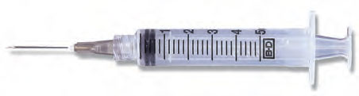

- The order reads, metoprolol 2.5 mg IV Push q 6 hours prn SBP>165. The vial contains metoprolol 5 mg in 5 mL. It is to be given over 5 minutes.
How many mL will be administered? 2.5 mL
Using the syringe below, calculate the number of lines per second. 1 line every 12 seconds
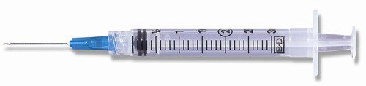
- The order reads, diltiazem 0.25mg/kg IV Push Now. The patient weighs 60 kg. The vial contains diltiazem 25mg in 5 mL. It is to be given over 3 minutes.
How many mg will the patient receive? 15 mg
How many mL will be administered? 3 mL
Using the syringe below, calculate the number of lines per second. 1 line every 6 seconds

