Review of Math Calculations
Rules of rounding:

If administering less than (<) 1 mL, round to nearest hundredth; a 1 mL syringe has calibrations to 0.01
< 1 mL, round to nearest hundredth

If administering (>)1 mL, round to nearest tenth; a 3 mL syringe has calibrations to 0.1
>1 mL, round to nearest tenth

Leading zeros: if an amount of medication is less than 1 mL, it must be written with a zero before the decimal point to prevent overdose of medication. Example: Give .5 mL = write 0.5 mL; .25 mg = write 0.25 mg

Trailing zeros: if amount of medication is a whole number, as 3 mL, do not write 3.0 mL to prevent potential overdose of medication

- Use this diagram when converting dosages within the metric system
- Move the decimal place three places for each step!

kg g mg mcg
. . . . . . . . . .

Common Conversions

Weight: 1 kg = 2.2 lbs
1 lb = 16 oz

Length: 1 inch = 2.54 cm

For weight and height ALWAYS round to the tenths!

Volume: Important MUST remember:
- 1 teaspoon (t) = 5 mL
- 1 ounce (oz) = 30 mL
- 1 Tablespoon (T) = 15 mL = 3 teaspoons

Systems Conversion Worksheet
Convert each of the given quantities to the equivalent unit indicated.

1. 1.5 g = __________ mg

2. 1.5 mg = __________ mcg

3. 3500 g = __________ kg

4. 125 mg = __________ g

5. 250 mcg = __________ mg

6. 1.5 L = __________ mL

7. 15 cm = __________ in

8. 50 inches = __________ cm

9. 30 kg = __________ lbs

10. 15 t = __________ mL

11. 10 in = __________ cm

12. 0.4 g = __________ mg

13. 220 lb = __________ kg

14. 5.3 kg = __________ g

15. 3500 g = __________ kg

16. 2 L = __________ mL

17. 32 mcg = __________ mg

18. 24 in = __________ cm

19. 56 mcg = _____________mg

20. A patient’s lunch consisted of the following fluids:

6 ounces of soup
360 mL of water
8 ounces of milk
6 ounces of gelatin
4 ounces of juice
120 mL of orange juice

Calculate the patient’s total fluid intake in ounces and mL.

____________ oz _____________ mL

Three Steps to Dosage
Calculations Formula Method

- Step 1. Convert
  - Ensure all measurements are in the same system of measurement and the same size unit of measurement.
  - If not, convert before proceeding.
- Step 2. Think
  - Estimate what is a reasonable amount of the drug to be administered.
- Step 3. Calculate Apply the formula

What you have : What you need

Dosage on hand = Dosage desired
Amount on hand X amount desired

Supply = Dosage
Have X amount
Oral Medications
- Order: Mirapex (pramipexole) 0.125 mg p.o. b.i.d.
Available: Mirapex 0.25 mg scored tablets.
How many tablet(s) should you administer? _________________________
- Order: Cytotec (misoprostol) 800 mcg p.o. to be given in 4 equally divided doses tid and hs.
Available: Cytotec 200 mcg tablets.
How many tablets should you administer each dose? _______________________

- Order: Oramorph SR (morphine sulfate) 15 mg po q 4-6 h prn pain. The patient received the last
dose at 1500. At what time could the patient receive the medication again? _______________

- Order Altace (ramipril) 5 mg po b.i.d.
Available: Altace in the figure below.
How many capsules should you administer? __________________________________

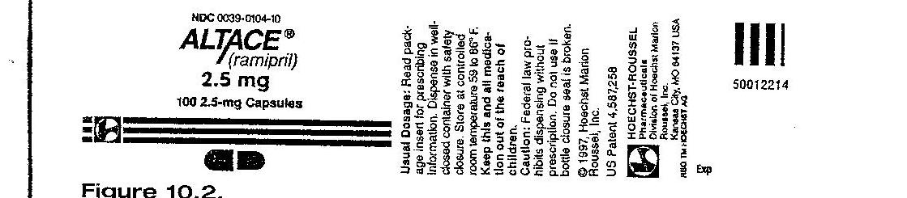

- Order Augmentin (amoxicillin/clavulanate) 800 mg oral suspension q 12h p.o.
Available: Augmentin in figure below:
Indicate on the medication cup the volume you should administer.

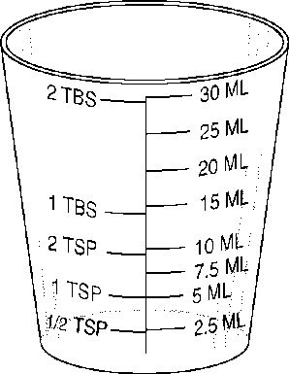

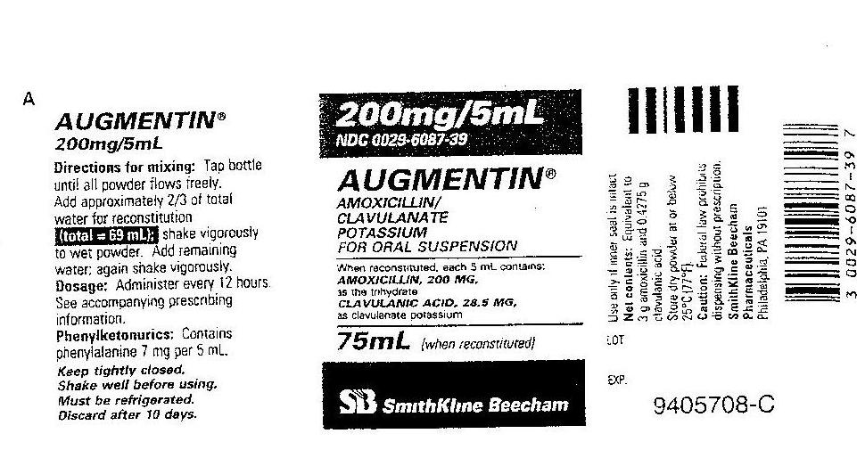

Parenteral Medications
- Order: Loxitan (loxapine hydrochloride) 30 mg IM q4h prn.
Available: 10 mL vial containing Loxitan 50 mg/mL.
How many mL should you administer? __________________________

- Order: Procainamide hydrochloride 500 mg IM now.
Available: Procainamide vial 1 g/2mL.
How many mL should you administer? __________________________

- Order: Valium (diazepam) 2.5 mg IV q 3h prn.
Available: Valium 2 mL vial containing 10 mg.
How many mL should you administer: _____________________________
The patient received Valium at 0300; when can the patient again receive the medication?
___________________________________

- Order: Cyanocobalamin 1000 mcg IM today. Available is a multidose vial containing cyanocobalamin 10 mg/10 mL.
Mark the syringe to indicate the dose to be administered.
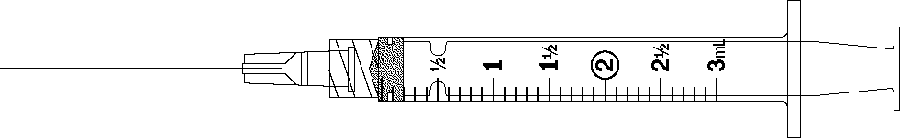

5. Order: Lovenox (enoxaparin sodium) 1 mg/kg subcut q 12h for a patient weighing 176 lbs.

What is the ordered dose q 12h? _______________________

6. Order: gentamicin 100 mg IV q 8h for a patient who weighs 220 lbs
The recommended adult dosage is 1 mg - 1.7 mg/kg/dose to be given q 8h.

Available: Gentamicin 80 mg/2 mL

Calculate the dose range: ______________mg to _______________mg

Is this a safe dose? (Yes or No) _________________

If this dosage is safe, how many mL will you administer? __________________

7. Order: Rocephin (sterile ceftriaxone sodium) 750 mg IM daily.
Available: A 1 g vial when reconstituted with 2.1 mL diluent yields a concentration of
350 mg/mL,

How many mL should you administer? _________________________________

8. Order: Erythromycin 750 mg IV every 6 hours.
Available: Erythromycin 1-g vial: reconstitute with 20 mL of sterile water for 1000 mg/20 mL

How many mL will you draw from the vial after reconstitution? ___________________

9. Order: Fortaz 1.25 g IV every 12 h

Available: Fortaz 2 g vial; dilute each 1 g with 10 mL sterile water for final concentration of 100 mg/mL.
How many mL will you draw from the vial after reconstitution? ___________________

10. Order: Vancomycin 275 mg IV every 8 h
Available: Vancomycin 500 mg vial; reconstitute each 500 mg vial with 10 mL NS for
final concentration of 50 mg/mL.
How many mL will you draw from the vial after reconstitution? ___________________

Concentration (per 1 mL)

Definition
- Concentration = Total Amount of Drug
Total Volume (mL)

- Weight over volume: W
V
- Heparin sodium 25,000 units in 250 ml D5W. What is the concentration?

Units/mL

- Doctor's order: Regular insulin 50 units in 250 mL NS. What is the concentration?

_______Units/mL

Calculating flow rates
- 2 definitions:
  - mL/hr – an infusion pump
  - gtt/min – manually counted (watch count)

Pump: mL/h
- > 1 hr: total mL = mL/hr
total hr

- < 1 hr: total mL x 60 min/hr = mL/hr
total min

Drops per Min: gtt/min
- total mL x drop factor gtt/mL = gtt/min
total min

IV Practice Problems GTT/MIN
- Order: 1000 mL D5W to run over 8 hours. The administration set is 15 gtt/mL. What is
the flow rate? _____________________ gtt/min

- Order: 1000 mL 0.9% Normal Saline to run over 6 hours. The administration set is 20
gtt/mL. What is the flow rate? _________________ gtt/min

- Order: The following IVs are to be infused over the next 18 hours. The administration set
is 15 gtt/mL. Calculate the flow rate for each of the IVs.
#1 1000 mL D₅W to run over 10 hours _________________ gtt/min
#2 500 mL NS to run over 4 hours ____________________ gtt/min
#3 250 mL LR to run over 4 hours ____________________ gtt/min

- The patient is to receive a transfusion of 1 unit of packed RBCs. The unit contains 250 mL and should infuse over 2 hours. The blood administration set is 10 gtt/mL.
What is the flow rate? _____________ gtt/min

- Order: 1000 mL D5LR to run over 9 hours. The administration set is 10 gtt/mL. What is the
flow rate? ____________ gtt/min

- Order: Kefzol (cefazolin sodium) 1 g q8h IV piggyback mixed in 100 mL NS to infuse
over 1 h. The administration set is 15 gtt/mL.
What is the flow rate? _____________ gtt/min

IV Practice Problems ML/HR
- Order: 1 g of ampicillin in 50 mL of D5W q 6h to infuse in 30 minutes. What is the flow
rate? ___________________mL/h

- Order: Garamycin (gentamicin sulfate) 60 mg IVPB q8h to infuse over 1 hr via infusion pump. Available: Garamycin 80 mg/2mL.
How many mL will you draw up? _____________mL
You add the Garamycin to 100 mL NS. What rate do you set the infusion pump?
____________________ mL/hr

- 1200 mL D₅W IV to infuse in 10 hours by infusion pump. What rate do you set the infusion pump?

_____________________ mL/h

- The order is for 2L D₅W IV to infuse in 24 hours by infusion pump. What rate do you set the infusion pump?

_____________________ mL/hr

- 1.5 L D₅ NS IV to infusion 20 hours by infusion pump. What rate do you set the infusion pump?

_____________________ mL/hr

- 30 mL D₅W with antibiotic IV to infuse in 20 minutes by infusion pump. What rate do you set the infusion pump?

_____________________ mL/hr

13. Calculate the IV flow rate for 250 mL to infuse by infusion pump over two hours. What is the infusion rate?

_____________________ mL/hr

Heparin & Insulin (All medications on are an infusion pump). Note: only Regular insulin can be used for an insulin IV drip!!!

1. Doctor's order: Heparin 50,000 units in 500 mL NS to infuse at 1200 units/hr.

The IV flow rate is: _______ mL/h

2. Doctor's order: Heparin 1800 units/hr and the pharmacy stock is a 500 mL NS bag containing Heparin 25,000 units.

The IV flow rate is: _________mL/h

3. Doctor's order: Heparin 25,000 units in 500 mL NS to run at 1700 units/hr.

The IV flow rate is: _______ mL/h

4. Doctor's order: Heparin 900 units/hr and you hav a 500 mL bag of D₅W containing Heparin 50,000 units.

The IV flow rate is: ________mL/h

5. Doctor's order: Heparin 25,000 units in 500 mL D₅W to run at 1400 units/hr

The IV flow rate is: ________ mL/h

6. Doctor's order: Regular insulin 7 units/hr IV and the stock is Regular insulin 50 units in 250 mL NS

The IV flow rate: _________ mL/h

7. Doctor's order: Regular insulin 100 units in 100 mL NS to infuse on a pump at 18 units/hr IV

The IV flow rate: __________mL/h

8. Doctor's order: Regular insulin 50 units in 100 mL NS to run at 12 units/hr IV

The IV flow rate: __________ mL/h

9. Doctor's order: Regular insulin 2 units/hr IV. Available supply is Regular insulin 50 units in 250 mL NS

The IV flow rate: ___________ mL/h

10. Doctor's order: Regular insulin 50 units in 500 mL NS to infuse on an IV pump at 10 units/hr

The IV flow rate: ___________ mL/h

Pediatric calculations

Directions: Calculate a single dose.
Calculate the child’s weight in kilograms, determine the safe recommended dosage or range, determine the safety of the order, and calculate the drug dose.
1. Order: Maintenance dose of Digoxin elixir 0.075 mg q 12h po for a 33 lb, 18-month-old child.
Manufacturer’s recommendation for maintenance dose: children under 2 years of age is 0.01-0.02 mg/kg daily in divided doses q 12h.
Available: Digoxin elixir 0.05 mg/mL.
Is the order safe: ______________
If safe, administer ______________mL

2. Order: Lasix 20 mg IM stat for a 7-year-old weighing 44 lbs.
Manufacturer’s recommended initial dose for Lasix is 1-2 mg/kg
Available: Lasix 40 mg/mL
Is the order safe: ______________
If safe, administer ______________mL

3. Order: Gentamycin 6 mg/kg/day in three divided doses IM for an 18-month-old who weighs 24 lb.
Manufacturer’s recommended dosage: 2-2.5 mg/kg q 8h.
Available: Gentamycin multi-dose vial 40 mg/mL
Is the order safe: _______________
If safe, administer ______________mL

4. Order: Ancef 30 mg/kg/day in 3 divided doses IM for a 9-month-old who weighs 32 lb.
Manufacturer’s recommended dosage: 25-50 mg/kg/day in 3 divided doses
Available: Ancef 500 mg: to reconstitute, dilute with 2 mL of sterile water to yield a volume of 2.2 mL.
Is the order safe: ____________
If safe, administer ______________mL

5. Order: Vistaril 0.5 mg/lb IM stat for a 10-year-old who weighs 35 kg
Manufacturer’s recommended dosage: 0.5 mg/lb/dose
Available: Vistaril muti-dose vial 25 mg/mL
Is the order safe: ____________
If safe, administer ______________mL

6. Order: Inderal 25 mg po bid for a 13-year-old weighing 99 lb
Manufacturer’s recommended pediatric dose is 0.5 mg/kg bid
Available: Inderal 10 mg/tab
Is the order safe: ____________
If safe, administer ______________tab(s)

7. Order: Amikacin 300 mg IM q 12h for an 11-year-old weighing 83 lb
Manufacturer’s recommended dosage: 7.5 mg/kg bid
Available: Amikacin single dose injectable 500 mg/2 mL
Is the order safe: ____________
If safe, administer ______________mL

8. Order: Clindamycin 15 mg po q 8h for a 12-month-old who weighs 19 lb
Manufacturer’s recommended dosage: 2-2.5 mg/kg/day in 3-4 divided doses.
Available: Clindamycin oral solution 10 mg/5 mL
Is the order safe: ____________
If safe, administer ______________mL

9. Order: Lanoxin pediatric elixir 120 mcg po q 8h for a 1-year-old who weighs 22 lb
Manufacturer’s recommended loading dose is 35-60 mcg/kg/day in 3 divided doses
Available: Lanoxin pediatric elixir 0.05 mg/mL
Is the order safe: ____________
If safe, administer ______________mL

10. Order: Demerol 1mg/kg IM stat. Child’s weight is 33 pounds.
Manufacturer’s recommended dose: 1 mg/kg
Available is Demerol 25 mg/mL.
Is the order safe: ____________
If safe, administer ______________mL

11. The physician orders Keflex 250 mg q.i.d. for a child weighing 50 lb. You have Keflex 250-mg capsules. The recommended daily po dosage for a child is 25 to 50 mg/kg/day in divided doses q 6 h.
Is the order safe: ____________
If safe, administer ______________cap(s)

12. The physician orders Benadryl 25 mg IV q6 h for a child weighing 50 lb. You have available Benadryl 12.5 mg/mL. The recommended daily dosage for a child weighing more than 12 kg is 5 mg- 7 mg/kg/24 h in four divided doses.
Is the order safe: ____________
If safe, administer ______________mL

13. The physician orders Dilantin 60 mg po q12 h for a child weighing 40 lb. You have Dilantin 30-mg chewable tablets available. The recommended oral dosage for a child is 5 to 7 mg/kg/24 h in divided doses q 12h.
Is the order safe: ____________
If safe, administer ______________tab(s)

14. Order: Dilantin 8 mg/kg/day p.o. divided into 2 doses. The manufacturer’s recommended dose is 8-10 mg/kg/day divided equally in 2 doses. The infant’s weight is 9 lbs 4 oz. Available is Dilantin Suspension 30 mg/5 mL.
Is the order safe: ____________
If safe, administer ______________mL

15. Order: Morphine sulfate 1 mg/kg/dose IV. Child weighs 40 lbs. Available is Morphine sulfate 10 mg/mL. Manufacturer’s recommended dose is 1 mg/kg/dose.
Is the order safe: ____________
If safe, administer ______________mL

16. Order: Phenobarbital 100 mg po q 12 h. The recommended maintenance dose is 3-5 mg/kg/day. The child weighs 30 kg. Available is Phenobarbital 50 mg/5 mL
Is the order safe: ____________
If safe, administer ______________mL

17. The recommended dose of Calcijex for IV use in children is 0.05 mcg/kg/day. Available is Calcijex single dose ampule with 2 mcg/mL. If 1.25 mcg IV is ordered, how much would you give a child weighing 55 lb?

Is the order safe: ____________
If safe, administer ______________mL

18. Order: Sandostatin 80 mcg subcut q 12h for a child weighing 18 lb.
Manufacturer’s recommended dose is 1-10 mcg/kg/day in 2 equally divided doses.
Available: Sandosatatin 100 mcg/mL
Is the order safe: ____________
If safe, administer ______________mL

19. Order: Prilosec 4.8 mg po qid for a child weighing 42 lb
Manufacturer’s recommended minimum dosage is 0.7 mg/kg/dose orally qid
Available: Prilosec 3 mg/mL
Is the order safe: ____________
If safe, administer ______________mL

- Order: Clindamycin 500 mg IVPB q 12 hours.
Available: A 1 gram vial that reads: “Add 3.5 mL of NSS to provide a final concentration 1 g/4 mL”.
The manufacturer’s instructions for IVPB administration suggests adding the Clindamycin to 250 mL D5W to be administered over 2 hours.

How many mL Clindamycin would you add to the bag of NS?
- Based on the previous question:

What is the flow rate you would set the infusion pump? mL/h

- Order: Regular insulin 3 units/hr IV
Available: Regular insulin 300 units in 200 mL NS

What is the concentration of the insulin drip? units/mL
- Based on the previous question:

What is the flow rate you would set on the infusion pump? mL/hr

NOTE: These problems will not be on a preclinical math test.
However, they may be on a theory exam.
Practice Problems Critical Care

For the following:
Weight in kilograms (round to the tenths)
Calculate ordered dose
Find the Concentration
READ THIS!
Infusion rates:
Volume per min (<1 round to hundredths, >1 round to tenths)
Volume per hour (round to tenths)
1. Infuse dobutamine 500 mg in 250 mL D5W at 5 mcg/kg/min. Patient weighs 182.6 lb.
Kg = 83 kg
Ordered dose = 83 kg x 5 mcg/kg/min = 415 mcg/min
Concentration = 500 mg = 500,000 mcg ÷ 250 mL = 2000 mcg/mL
Volume per minute = 415 mcg/min ÷ 2000 mcg/mL = 0.207 = 0.21 mL/min
Volume per hour = 0.21 mL/min x 60 min/hr = 12.6mL/h

2. Infuse amrinone 250 mg in 250 mL NS at 5 mcg/kg/min. Patient weighs 165 lbs
Volume per minute = ________________
Volume per hour = __________________

3. Infuse dopamine 400 mg in 250 mL D5W at 10 mcg/kg/min. Patient weighs 140.8 lb
Volume per minute = ________________
Volume per hour = __________________

4. Infuse nitroprusside 100 mg in 500 mL D5W at 3 mcg/kg/min. Patient weighs 55 kg
Volume per minute = ________________
Volume per hour = __________________

5. Infuse dobutamine 1000 mg in 500 mL D5W at 15 mcg/kg/min. Patient weighs 110 lb
Volume per minute = ________________
Volume per hour = __________________

6. Infuse propofol (Diprivan) 500 mg/50 mL at 10 mcg/kg/min. Patient weighs 187 lb
Volume per minute = ________________
Volume per hour = __________________

7. Infuse alfentanil (Alfenta) 10,000 mcg in D5W 250 mL at 0.5 mcg/kg/min. Patient weighs 176 lb
Volume per minute = ________________
Volume per hour = __________________

8. Infuse milrinone (Primacor) 20 mg in D5W 100 mL at 0.375 mcg/kg/min. Patient weighs 160.6 lb.
Volume per minute = ________________
Volume per hour = __________________

9. Infuse esmolol 2.5 g in NS 250 mL at 150 mcg/kg/min. Patient weighs 149.6 lb
Volume per minute = ________________
Volume per hour = __________________

10. Infuse theophylline 400 mg in D5W 500 mL at 0.55 mg/kg/hr. Patient weighs 70 kg. Note: you are given the hourly rate only
Volume per hour = __________________

- The order reads, furosemide 40 mg IV Push, once. The vial contains furosemide 40mg in 4 mL. It is to be given over 2 minutes.

How many mL will be administered? ___________

Using the syringe below, calculate the number of lines per second. ____________
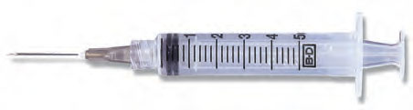

- The order reads, metoprolol 2.5 mg IV Push q 6 hours prn SBP>165. The vial contains metoprolol 5 mg in 5 mL. It is to be given over 5 minutes.
How many mL will be administered? _____________
Using the syringe below, calculate the number of lines per second. ______________
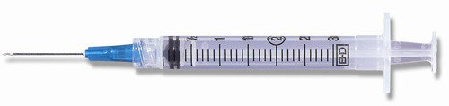
- The order reads, diltiazem 0.25mg/kg IV Push Now. The patient weighs 60 kg. The vial contains diltiazem 25mg in 5 mL. It is to be given over 3 minutes.
How many mg will the patient receive? __________
How many mL will be administered? __________
Using the syringe below, calculate the number of lines per second. ___________

