Delaware Technical Community College
Nursing Department

Nursing Skills #1 Sign Off

Hand washing
1. | Turn the water on (cold and hot) warm water, not too hot.
2. | Apply soap, enough to form a good lather.
3. | Keep your clothing away from the sink and hands down in the sink
4. | Wash hands for 20 seconds taking care to clean the palms, back of hands, in between fingers and fingernails.
5. | Rinse thoroughly making sure to remove all soap (soap can dry skin, which can lead to cracked skin which can lead to entry ways for infection).
6. | Drip dry in the sink – do not shake.
7. | Dry hands thoroughly and discard paper towels.
8. | Use clean/dry paper towels to turn off the facets then discard.

Three (3) reasons you must wash your hands with soap and water:
- Hands are visibly soiled.
- You have cared for a patient with C-Diff or Norovirus.

Otherwise you may use hand sanitizing gel. Make sure you get in between each finger and under your fingernails. Use only the hospital supplied lotions, hand sanitizers and soaps as they are designed to work together.

Isolation (Personal Protective Equipment – PPE)
 | Donning PPE |  | Removing PPE
1. | Gown – clothing on your back must be completely enclosed | 1. | Gloves
2. | Mask | 2. | Goggles
3. | Goggles | 3. | Gown (untie top tie first, then waist tie)
4. | Gloves | 4. | Mask

Vital Signs (dialogue included)
1 | Wash your hands
2 | Knock Knock….
3 | Introduce yourself - “Hi my name is …. I’ll be your student nurse.”
4 | Ask the patient to see their arm band – “May I see your armband?”
5 | Ask patient to verify – “Can you tell me your name and date of birth?” “Do you have any allergies?”
6 | Tell the patient – “I’m here to take your vital signs.” “I’m going to take your temperature first.”
7 | Ask the patient – “Have you had anything hot or cold to drink in the last 15-minutes?” Have you had any gum or tobacco products?” Allow the patient to respond.
8 | Explain to the patient what you’re doing “I’m going to take the thermometer and place it under your tongue back by the molars.” Wait for the thermometer to beep.
9 | Once the temperature reading has completed, you will describe the normal values. 98.6℉ or 37℃
10 | Make sure you know the temperature scale that is listed in the textbook
11 | Explain what you’re going to do next to the patient – “Next, I’m going to check your pulse.”
12 | Place your fingers for 30-seconds at the patient’s radial pulse, if the pulse is irregular, then you will check the pulse for 1-minute. (Normal pulse range – 60-100 beats per/min (30 sec X 2= beats per/min)
13 | While your finger is still on the radial pulse, you will count the patient’s respirations.  (Normal Respirations rate 12-20 breathes per/min (30 sec X 2= per/min)
14 | After completing temperature and pulse readings, explain to the patient what’s next. “I’m going to check your pulse oximetry.”
15 | Place the device a finger with no nail polish, if it does, turn the devise on the side of the finger to get the reading. Make sure the arm is hanging down to get an accurate reading. (Normal Pulse OX range – 92% -100%)
16 | Next ask the patient about their pain  “Mr./Mrs.…. Do you have any pain?”  “Where is your pain?”  “On a scale of 0 to 10 – 0 means no pain, and 10 is the worse pain you can imagine”  “Can you describe your pain? (sharp, aching, etc.)”  “Does it radiate?”  “How long have you had this pain?”  “Does anything make it better or worse?”  Explain to the patient “I’ll check their chart to see if they have prescribed anything for it.”
17 | Explain to the patient what you’re going to do next. “Next, I’m going to check your blood pressure, but before I start – is there any reason why I can’t take your blood pressure in either arm?”

The reasons why you would not be able to take a blood pressure reading:
- Running IV
- AV or Dialysis ➛ Shunt / Graft / Fistula
- PICC line - (peripherally inserted central catheter)
- Implanted birth control
- Lymph nodes removed
- Mastectomy
18 | Place the cuff on the arm correctly and be sure the patient is not crossing their legs
19 | You will obliterate the pulse – when you don’t feel their pulse that is when you’ll notice the number on the gauge. (systolic)
20 | Add 30 to the number on the gauge that you found when the patient’s pulse was obliterated
21 | Allow the patient 30 seconds to rest, then you will take the blood pressure – listening for the very first beat and the last beat. (systolic/diastolic)
22 | Remove the blood pressure cuff from the patient. Tell the patient their blood pressure reading “Your blood pressure is…”
23 | Tell the patient “Thank you for your time.”
24 | Wash your hands and then exit the room.

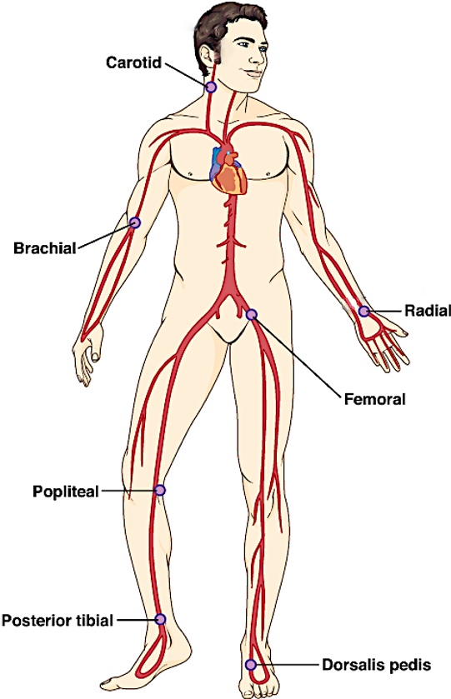
Peripheral Pulse site
Site | Location
Carotid | The sides of the neck beside the trachea
Brachial | The medial aspect of the antecubital space
Radial | At the base of the thumb
Femoral | Wearing gloves - in the groin at the top of the thigh
Popliteal | Lateral aspect behind the knee
Posterior Tibialis | Medial aspect of the ankle, directly behind the malleolus
Dorsalis pedis | Between the great toe and second toe midway up the foot

